**Case Study Report**

***(A Community-Based Study on the Causes and Effects of Fly Infestation)***

**1. EXECUTIVE SUMMARY**

This case study investigates community-reported fly infestation patterns across several barangays in Aklan and Antique provinces. The study aimed to understand the frequency of fly sightings, potential contributing factors such as garbage handling, water stagnation, weather, and the presence of fruit-bearing plants, and to identify areas with heightened discomfort or potential health risks.

Using a structured survey distributed among residents, the responses of 28 participants were cleaned and analyzed using descriptive statistics, non-parametric tests (Kruskal-Wallis, Wilcoxon), and visual plots in R. Key insights include Ibajay municipality showing the highest reported fly frequency, hot/dry weather being most associated with increased fly presence, and a trend linking discomfort to areas with frequent fly sightings.

While statistical significance was not observed in most relationships—likely due to the limited sample size—valuable trends emerged that can inform local sanitation planning and further research.

**2. INTRODUCTION**

Flies are not only a nuisance in households but also known carriers of pathogens that pose health risks in rural and urban communities. In the context of Aklan and Antique provinces, anecdotal reports from residents have raised concerns over increasing fly infestations, particularly during certain seasons and in proximity to potential breeding sources such as poultry farms and unmanaged waste.

This study was conducted to explore:

* The extent and frequency of fly presence as experienced by community members;
* Whether environmental factors such as stagnant water, fruit-bearing plants, and garbage collection frequency contribute to perceived fly problems;
* Which areas may require targeted sanitation or health interventions.

The study's broader objective is to provide baseline evidence that could assist barangay-level decision-makers in addressing fly-related discomfort and health concerns.

**3. METHODOLOGY**

**a. Data Collection:**

A survey was developed with both closed and semi-open questions, targeting adult residents (18 and above). Respondents provided information on:

* Location (Province, Municipality, Barangay),
* Environmental conditions (garbage, water, fruit plants),
* Fly frequency and related discomfort,
* Weather when flies are often noticed,
* Health symptoms associated with fly presence.

Surveys were administered online and via local outreach between July 5–6, 2025.

**b. Data Cleaning & Encoding**

Raw responses were cleaned in Excel and analyzed in R. Text responses were:

* Standardized (e.g., "IBAJAY" → "Ibajay"),
* Converted to ordinal scales (e.g., fly frequency: Never = 1, Every day = 4),
* Recoded into consistent categories (e.g., weather responses into 4 types).

**c. Data Analysis**

The study used:

* **Descriptive Statistics** to summarize trends;
* **Kruskal-Wallis tests** to compare non-normal ordinal groups (e.g., fly frequency across municipalities);
* **Wilcoxon Rank-Sum Test** to compare two proximity groups (e.g., barangays near vs. far from Regador);
* **Bar and box plots** for visual insight using ggplot2 in R.

**4. DATA ANALYSIS**

**a. Data Cleaning and Preparation**

The dataset consisted of **28 valid responses** (after initial cleaning), collected from residents of different barangays across multiple municipalities in Aklan and Antique. The raw responses included categorical and ordinal data, which were standardized for analysis. Key steps included:

* Converting text inputs into **ordinal scales** (e.g., fly frequency: Never = 1 to Every day = 4).
* Removing blanks and harmonizing inconsistent labels (e.g., “IBAJAY” and “Ibajay” → “Ibajay”).
* Recoding qualitative responses such as **weather conditions** and **fruit-bearing plant effects** into simplified categories (e.g., "Hot/Dry Season", "Rainy/Wet Season", "Not Sure").

**b. Descriptive Statistics**

* **Fly Frequency** ranged from **1 to 4**, with most respondents selecting **3 (A few times a week)**.
* **Discomfort Levels** were reported on a scale of 1 (no discomfort) to 5 (very high), with a median of **4**.
* **Garbage Collection** frequency varied, with some areas reporting “Weekly” and others “Rarely.”
* Respondents were mainly from **Ibajay**, with other entries from Tangalan, Nabas, Malay, and Pandan.

**c. Inferential Analysis**

**Kruskal-Wallis Test**

Used to compare differences in fly frequency across groups since the data was ordinal and not normally distributed.

|  |  |  |  |
| --- | --- | --- | --- |
| **Comparison** | **Test Result (χ², df)** | **p-value** | **Interpretation** |
| Fly Frequency vs Municipality | 9.35, 5 | 0.096 | Not significant, but shows possible trend |
| Fly Frequency vs Fruit Plants | 4.29, 3 | 0.2315 | Not significant |
| Fly Frequency vs Garbage Collection | 4.77, 4 | 0.3117 | Not significant |
| Fly Frequency vs Water Stagnant | 0.40, 2 | 0.8198 | No significant difference |

**Wilcoxon Rank Sum Test**

Compared barangays **near vs. far from Regador**:

Result: **W = 39, p = 0.55** → No significant difference, though nearby barangays reported slightly higher fly presence.

**d. Visual Analysis**

* **Boxplots and bar charts** were used to visualize the distributions.
* Graphs showed **Ibajay** with more frequent high fly scores.
* **Hot/dry seasons** were most commonly associated with increased fly presence.
* Respondents with **fruit-bearing plants** who noticed increased fly presence had **higher fly scores** in general.

**e. Correlation Check**

While not statistically tested, a **visual positive trend** was observed between:

* **Fly frequency** and **discomfort level**
* **Garbage piling** and **discomfort**

These suggest a potential pattern that may emerge more clearly with a larger dataset.

**5. Findings**

**a. Fly Frequency**

Respondents reported varying levels of fly presence, within Ibajay municipality showing the highest frequency overall. Several residents there indicated they often see large numbers of flies, compared to other municipalities where fly frequency was lower.

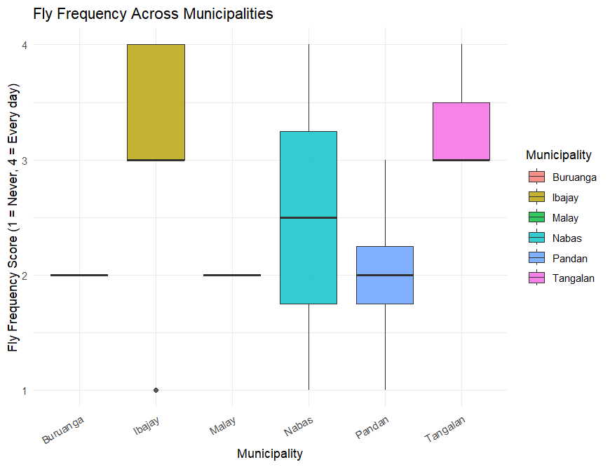

**b. Weather Influence**

When asked when they observe more flies, the majority of respondents indicated hot/dry season, followed by the rainy/wet season. A few reported no noticeable change, while others were unsure. This suggests that weather conditions may affect fly activity or visibility as perceived by residents.

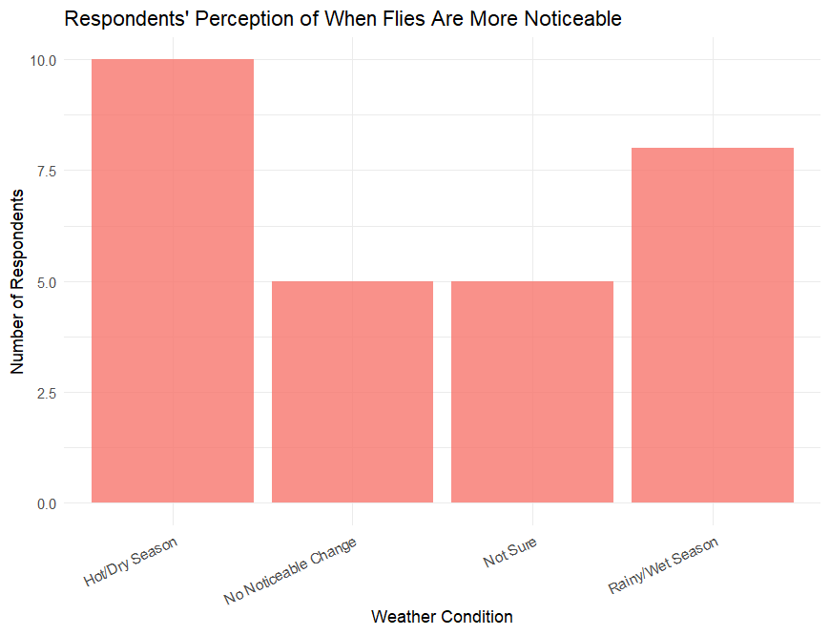

**c. Fruit-Bearing Plants**

Respondents with fruit-bearing plants, especially those who noticed more flies when the plants were bearing fruit, tended to report higher fly frequency. However, the difference was not statistically significant based on the Kruskal-Wallis test (p = 0.23), likely due to limited sample size.

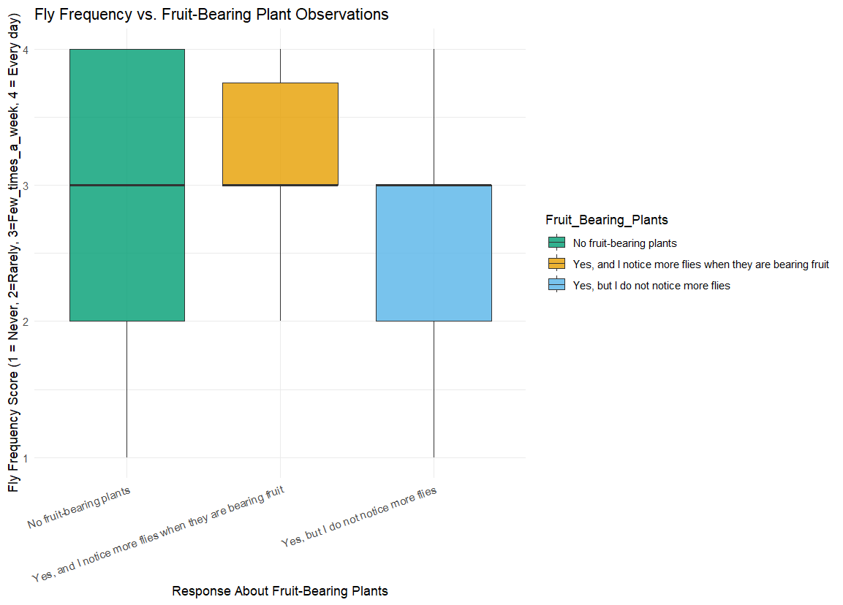

**d. Waste Management**

No strong statistical relationship was found between the frequency of garbage collection or garbage piling and fly presence (p > 0.3). However, visual analysis showed that areas with less frequent collection and more piling tended to have higher discomfort and slightly higher fly activity.

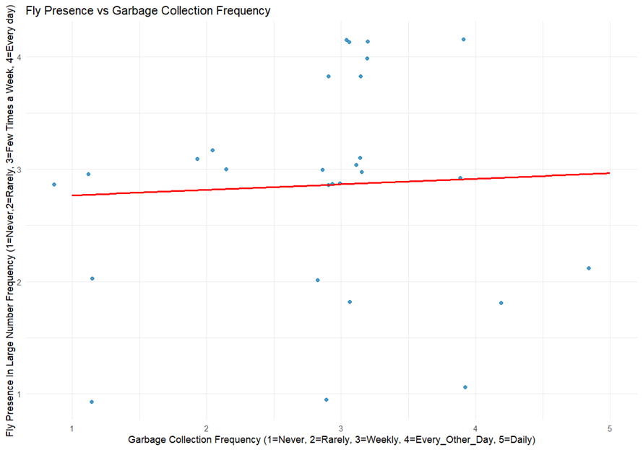

**f. Water Stagnation**

Respondents who reported stagnant water did not significantly differ in fly presence compared to others (p = 0.82), but this may require further study with better indicators.

**g. Local Perception (Regador)**

While some local anecdotes claim that Barangay Regador is a source of flies due to poultry, the only respondent from Regador reported the lowest fly frequency. Barangays near Regador showed slightly higher fly frequency compared to those farther away, but this difference was not statistically significant (p = 0.55).

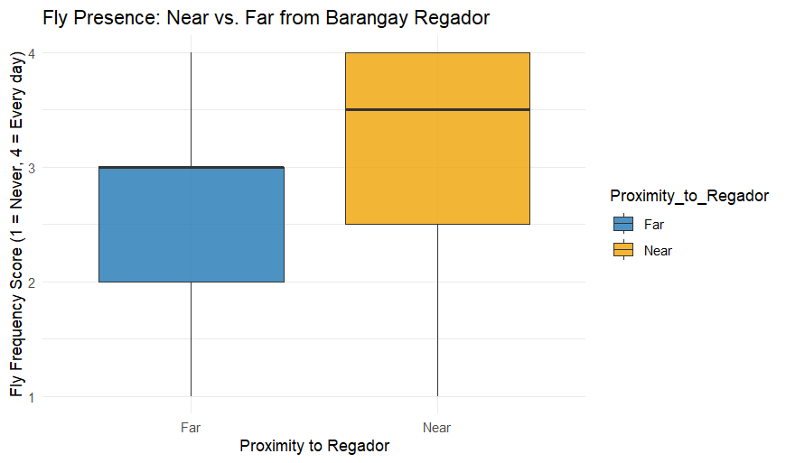

**h. Discomfort and Health**

Many respondents who reported more frequent fly presence also reported higher discomfort levels, and a few mentioned health symptoms like diarrhea and skin irritation. A positive correlation between fly frequency and discomfort was visually evident.

**6. Conclusion**

This study highlights community perceptions and experiences regarding fly infestation in various barangays. Although **statistical tests did not reveal strong significance**, clear **visual patterns** and **local knowledge** point to **Ibajay** and **barangays near Regador** as areas with higher perceived fly presence. Weather, fruit-bearing plants, and waste management practices may all play roles in perceived fly infestations, though more data is needed for stronger conclusions.

**7. Recommendations**

**Targeted Sanitation Programs**  
Focus waste management and sanitation campaigns in **Ibajay and nearby barangays**, where fly frequency and discomfort are reportedly highest.

**Regular Garbage Collection**  
Ensure garbage is collected consistently, especially in hot/dry seasons when fly activity is more noticeable.

**Monitor Fruit-bearing Areas**  
Encourage proper disposal of overripe fruit and compost management in homes with fruit-bearing plants.

**Community Education**  
Educate residents about fly breeding grounds, especially during warmer months, and promote home sanitation practices.

**Further Study**  
Collect more responses across barangays and add **geographic and seasonal tracking** to strengthen statistical power and possibly use mapping tools (e.g. GIS) for visual impact.

**8. Appendices**

**Appendix A – Survey Questionnaire**

1 What is your age group?

2 Province, Municipality, and Barangay

3 How frequent is garbage collection in your area?

4 Do you often see garbage piling up in your surroundings?

5 Do you notice stagnant water near your home?

6 How frequently do you see a large number of flies?

7 Have you or your household experienced any health issues related to flies?

8 On a scale of 1–5, how uncomfortable are you with the presence of flies?

9 During what weather do you usually see more flies?

10 Do you have fruit-bearing plants at home? Do you notice more flies then?

**Appendix B - Ordinal Scale Conversion**

|  |  |  |
| --- | --- | --- |
| **Variable** | **Original Response** | **Converted Scale** |
| Garbage Collection | Never, Rarely, Weekly, Every Other Day, Daily | 1–5 |
| Garbage Piling | Never, Rarely, Sometimes, Always | 1–4 |
| Water Stagnant | No, I'm not sure, Yes | 1–3 |
| Number of Flies | Never, Rarely, A few times a week, Every day | 1–4 |
| Discomfort Level | 1–5 | 1–5 |

**Appendix C – Sample Data (Anonymized)**

|  |  |  |  |  |  |  |  |
| --- | --- | --- | --- | --- | --- | --- | --- |
| **Age Group** | **Municipality** | **Barangay** | **Garbage Collection** | **Water Stagnant** | **Fly Frequency** | **Discomfort** | **Weather Response** |
| 18 and above | Ibajay | Naile | Weekly | No | Every day | 5 | During hot/dry season |
| 18 and above | Tangalan | Napatag | Weekly | Yes | A few times/wk | 3 | During rainy/wet season |
| 18 and above | Nabas | Unidos | Every other day | Yes | A few times/wk | 4 | During hot/dry season |

**Appendix D – Statistical Test Result**

Kruskal-Wallis Test – Fly Frequency by Municipality

* χ² = 9.35
* df = 5
* p = 0.096

Wilcoxon Rank-Sum Test – Proximity to Regador

* W = 39
* p = 0.5516

Kruskal-Wallis Test – Fly Frequency by Fruit-Bearing Plants

* χ² = 4.29
* df = 3
* p = 0.2315

Kruskal-Wallis Test – Fly Frequency by Garbage Collection Frequency

* χ² = 4.77
* df = 4
* p = 0.3117

Kruskal-Wallis Test – Fly Frequency by Water Stagnation

* χ² = 0.40
* df = 2
* p = 0.8198

**Appendix E – Code Snippet (R)**

# Convert text responses to ordinal values

flies_data <- flies_data %>%

mutate(Garbage_Collection = recode(Garbage_Collection,

"Never" = 1, "Rarely" = 2, "Weekly" = 3, "Every other day" = 4, "Daily" = 5

))

# Kruskal-Wallis test for fly frequency by municipality

kruskal.test(as.numeric(Number_of_Flies) ~ Municipality, data = flies_data)

# Plotting fly frequency by weather

ggplot(flies_data, aes(x = Weather_Clean, y = as.numeric(Number_of_Flies))) +

geom_boxplot()